ASEAN-Korea Partnership Vital for Regional Digital Transformation

Jakarta, 13 July 2023 – The partnership between ASEAN and South Korea is crucial for accelerating digital transformation in the Southeast Asian region. As a country with expertise in digital innovation, South Korea can support ASEAN in the development of digital innovation and infrastructure.

This was conveyed by the Minister for Foreign Affairs of Indonesia, Retno Marsudi, during the meeting of ASEAN Foreign Ministers with the Foreign Minister of South Korea in Jakarta (13/7). Next year marks the 35th anniversary of ASEAN-South Korea relations, and the plan to launch the Comprehensive Strategic Partnership between the two countries.

Foreign Minister Retno stated that there are two areas of cooperation that need to be promoted.

First, accelerating digital infrastructure development in ASEAN.

This year, ASEAN's economic growth is projected to reach 4.7%. To maintain this momentum, investment in digital transformation infrastructure is needed, particularly in communication infrastructure, digital innovation in the banking sector, and digital payments.

"As a global powerhouse for digital innovation, South Korea can help ASEAN in attaining development in this crucial sector, including by rendering support on the planned “ASEAN-Indo-Pacific Forum: Implementation of the AOIP," said Foreign Minister Retno.

Second, maintaining commitment towards lasting peace and stability in the region. The ongoing developments on the Korean Peninsula are a concern for the region. Nuclear weapons pose a significant threat to the Indo-Pacific region.

"ASEAN is committed to nurture the habit of dialogue, and the paradigm of collaboration, by utilizing all ASEAN platforms, such as the ASEAN Regional Forum (ARF). The planned ASEAN-South Korea Joint Statement on the AOIP must be geared in an inclusive manner and contribute to lasting peace and stability in the region," emphasized Foreign Minister Retno.

During the meeting, ASEAN countries welcomed the Korean-ASEAN Solidarity Initiative (KASI), which emphasizes ASEAN centrality, strengthens strategic cooperation in the political and security fields, and explores cooperation in digital infrastructure and climate change.

In the cultural field, discussions were held on enhancing people-to-people contacts and socio-cultural cooperation, including the inauguration of ASEAN-Korea Day at the end of 2023. In the economic field, the importance of cooperation in advancing micro, small, and medium enterprises (MSMEs) was discussed, including the enhancement of innovation skills and digital economy.

Regarding peace and security, emphasis was placed on the importance of peace in the Korean Peninsula.

The meeting also encouraged the finalization of elevating the status of the ASEAN-Korea partnership to a Comprehensive Strategic Partnership, coinciding with the commemoration of the 35th anniversary of ASEAN-Korea dialogue relations next year.

The Joint Statement of ASEAN Foreign Ministers on the launch of ballistic missiles on the Korean Peninsula is available on the ASEAN Secretariat website (https://asean.org/wp-content/uploads/2023/07/AMS-Statement-on-Korean-Peninsula.pdf).

***

For further information, please contact the following:

Director for Information and Media of the Ministry of Foreign Affairs - Hartyo Harkomoyo (+62811831899)

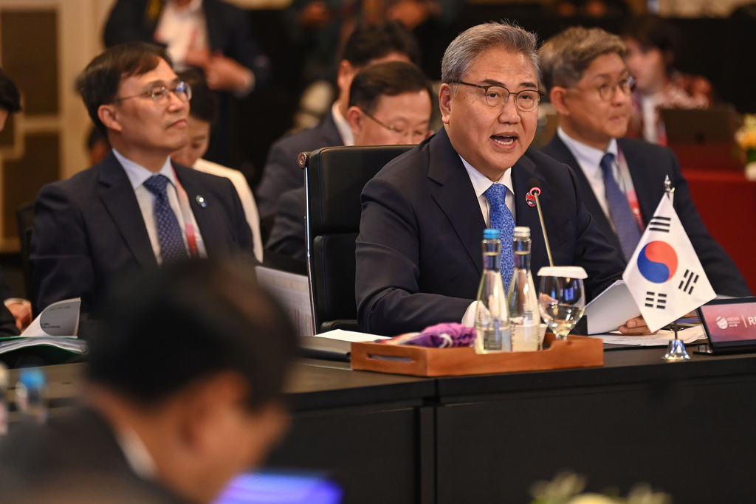

The partnership between ASEAN and South Korea is crucial for accelerating digital transformation in the Southeast Asian region was highlighted during the meeting of ASEAN Foreign Ministers with the Foreign Minister of South Korea in Jakarta (13/7) (Photo: Ministry of Foreign Affairs of Indonesia).

